JSF

* CREATE DYNAMIC PROJECT
* INTEGRATE APACHACE TOMCAT

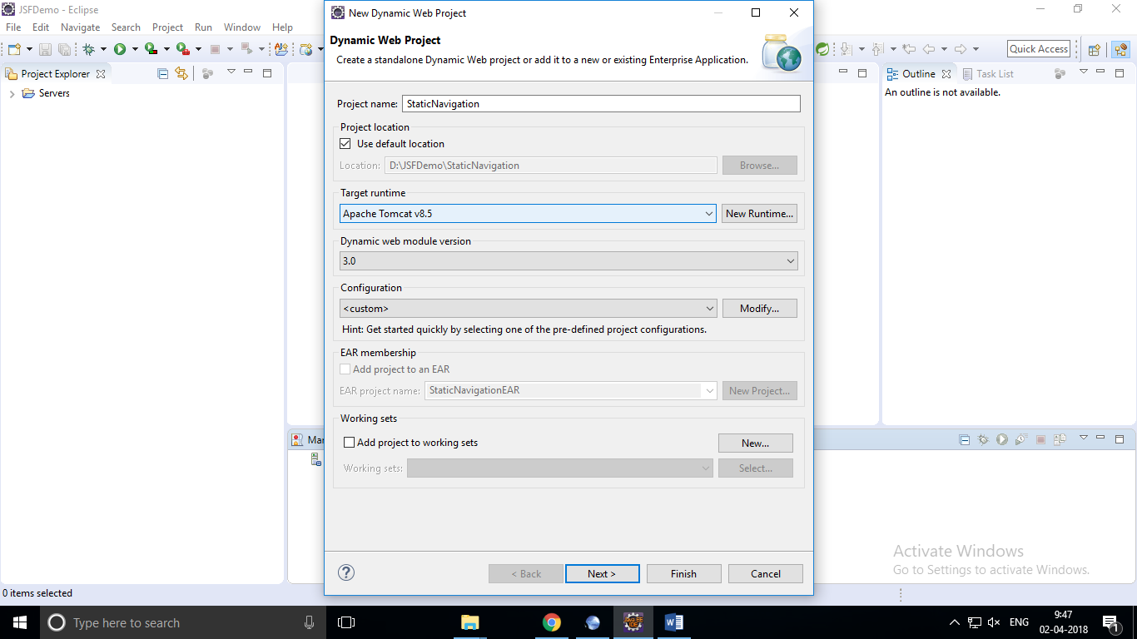

GENERATE WEB.XML:

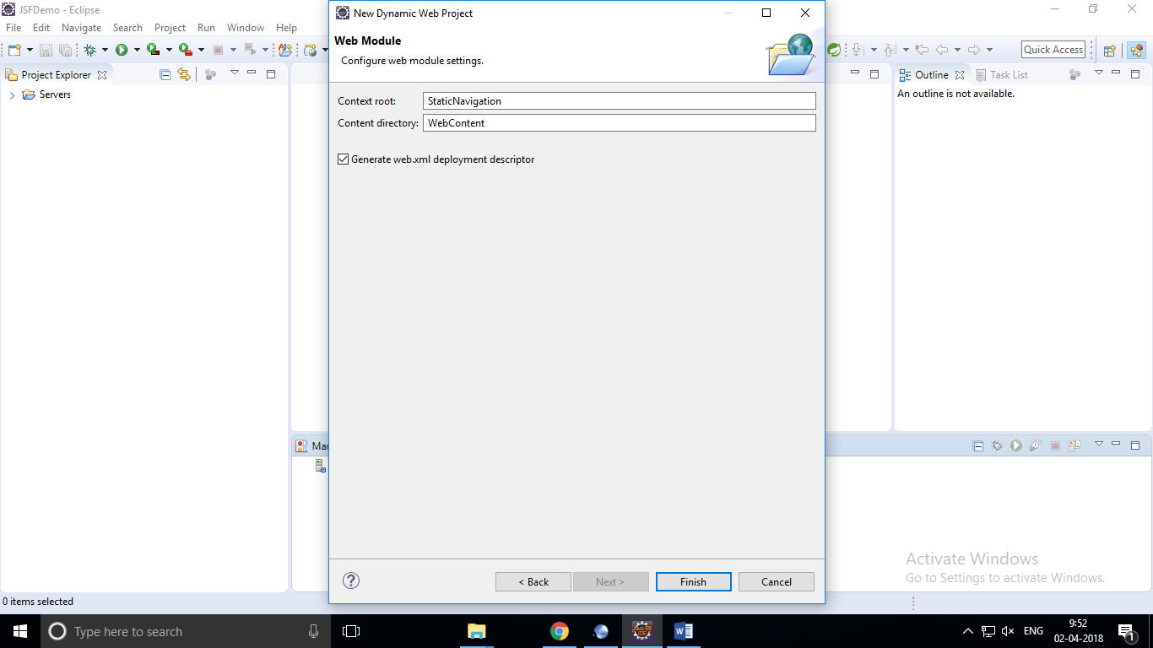

WEB.XML:

<?xml version=*"1.0"* encoding=*"UTF-8"*?>

<web-app xmlns:xsi=*"http://www.w3.org/2001/XMLSchema-instance"* xmlns=*"http://java.sun.com/xml/ns/javaee"* xsi:schemaLocation=*"http://java.sun.com/xml/ns/javaee http://java.sun.com/xml/ns/javaee/web-app_3_0.xsd"* id=*"WebApp_ID"* version=*"3.0"*>

<display-name>StaticNavigation</display-name>

<welcome-file-list>

<welcome-file>index.html</welcome-file>

<welcome-file>index.htm</welcome-file>

<welcome-file>index.jsp</welcome-file>

<welcome-file>default.html</welcome-file>

<welcome-file>default.htm</welcome-file>

<welcome-file>default.jsp</welcome-file>

</welcome-file-list>

<servlet>

<servlet-name>Faces Servlet</servlet-name>

<servlet-class>javax.faces.webapp.FacesServlet</servlet-class>

<load-on-startup>1</load-on-startup>

</servlet>

<servlet-mapping>

<servlet-name>Faces Servlet</servlet-name>

<url-pattern>*.jsf</url-pattern>

</servlet-mapping>

</web-app>

Faces-Config.xml:(under web-INF folder)

<?xml version=*"1.0"* encoding=*"UTF-8"*?>

<faces-config xmlns=*"http://java.sun.com/xml/ns/javaee"*

xmlns:xsi=*"http://www.w3.org/2001/XMLSchema-instance"*

xsi:schemaLocation=*"http://java.sun.com/xml/ns/javaee*

*http://java.sun.com/xml/ns/javaee/web-facesconfig_2_0.xsd"*

version=*"2.0"*>

<navigation-rule>

<from-view-id>/Main.jsp</from-view-id>

<navigation-case>

<from-outcome>first</from-outcome>

<to-view-id>/First.jsp</to-view-id>

</navigation-case>

<navigation-case>

<from-outcome>second</from-outcome>

<to-view-id>/Second.jsp</to-view-id>

</navigation-case>

</navigation-rule>

</faces-config>

Copy and paste jar files under lib folder:



Main.jsp:

<%@ page language=*"java"* contentType=*"text/html; charset=UTF-8"*

pageEncoding=*"UTF-8"*%>

<%@taglib uri=*"http://java.sun.com/jsf/core"* prefix=*"f"*%>

<%@taglib uri=*"http://java.sun.com/jsf/html"* prefix=*"h"*%>

<!DOCTYPE >

<html>

<f:view>

<head>

<title>Static Navigation</title>

</head>

<body>

<h1 align=*"center"*>Main Page</h1>

<hr size=*"2"*>

<div align =*"center"*>

<h:form>

<h:commandButton value=*"go first"* action=*"First"* />

<h:commandButton value=*"go second"* action=*"Second"* />

</h:form>

</div>

</body>

</f:view>

</html>

First.jsp:

<%@ page language=*"java"* contentType=*"text/html; charset=UTF-8"*

pageEncoding=*"UTF-8"*%>

<%@taglib uri=*"http://java.sun.com/jsf/core"* prefix=*"f"*%>

<%@taglib uri=*"http://java.sun.com/jsf/html"* prefix=*"h"*%>

<!DOCTYPE html>

<html>

<f:view>

<head>

<title>Insert title here</title>

</head>

<body>

<h1 align=*"center"*>First Page</h1>

<hr size=*"2"* />

<h:form>

<h:commandLink value=*"go home"* action=*"Main"* />

</h:form>

</body>

</f:view>

</html>

Second.jsp:

<%@ page language=*"java"* contentType=*"text/html; charset=UTF-8"*

pageEncoding=*"UTF-8"*%>

<%@taglib uri=*"http://java.sun.com/jsf/core"* prefix=*"f"*%>

<%@taglib uri=*"http://java.sun.com/jsf/html"* prefix=*"h"*%>

<!DOCTYPE html>

<html>

<f:view>

<head>

<title>Insert title here</title>

</head>

<body>

<h1 align=*"center"*>second Page</h1>

<hr size=*"2"* />

<h:form>

<h:commandLink value=*"go home"* action=*"Main"* />

</h:form>

</body>

</f:view>

</html>

Face-config.xml:

<?xml version=*"1.0"* encoding=*"UTF-8"*?>

<faces-config xmlns=*"http://java.sun.com/xml/ns/javaee"*

xmlns:xsi=*"http://www.w3.org/2001/XMLSchema-instance"*

xsi:schemaLocation=*"http://java.sun.com/xml/ns/javaee*

*http://java.sun.com/xml/ns/javaee/web-facesconfig_2_0.xsd"*

version=*"2.0"*>

<navigation-rule>

<from-view-id>/Main.jsp</from-view-id>

<navigation-case>

<from-outcome>first</from-outcome>

<to-view-id>/First.jsp</to-view-id>

</navigation-case>

<navigation-case>

<from-outcome>second</from-outcome>

<to-view-id>/Second.jsp</to-view-id>

</navigation-case>

</navigation-rule>

<navigation-rule>

<from-view-id>/First.jsp</from-view-id>

<navigation-case>

<from-outcome>home</from-outcome>

<to-view-id>/Main.jsp</to-view-id>

</navigation-case>

</navigation-rule>

<navigation-rule>

<from-view-id>/Second.jsp</from-view-id>

<navigation-case>

<from-outcome>home</from-outcome>

<to-view-id>/Main.jsp</to-view-id>

</navigation-case>

</navigation-rule>

</faces-config>

Output:

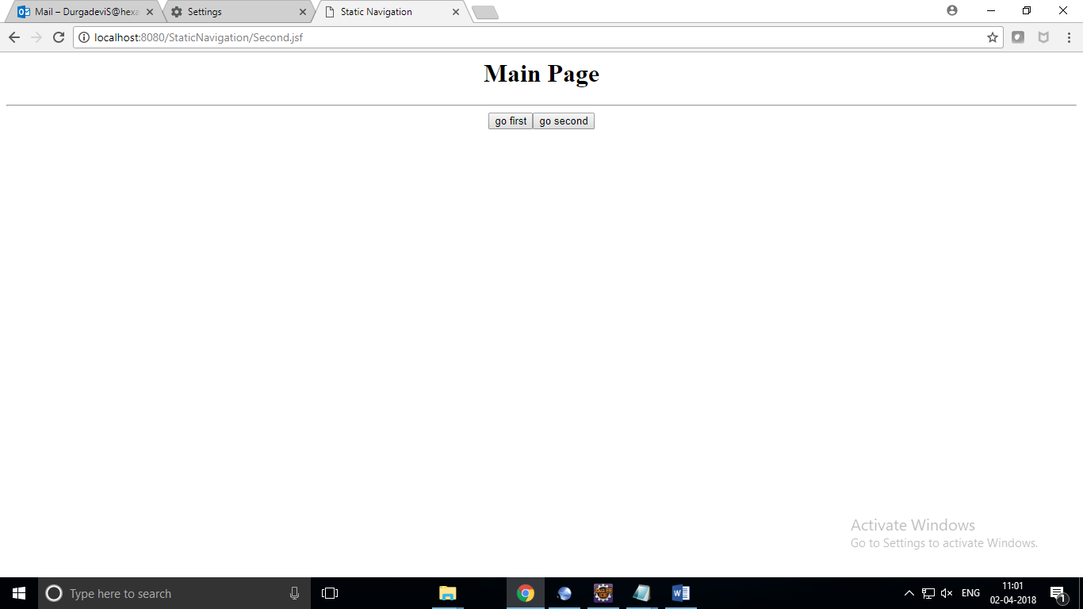

Clicking go to first

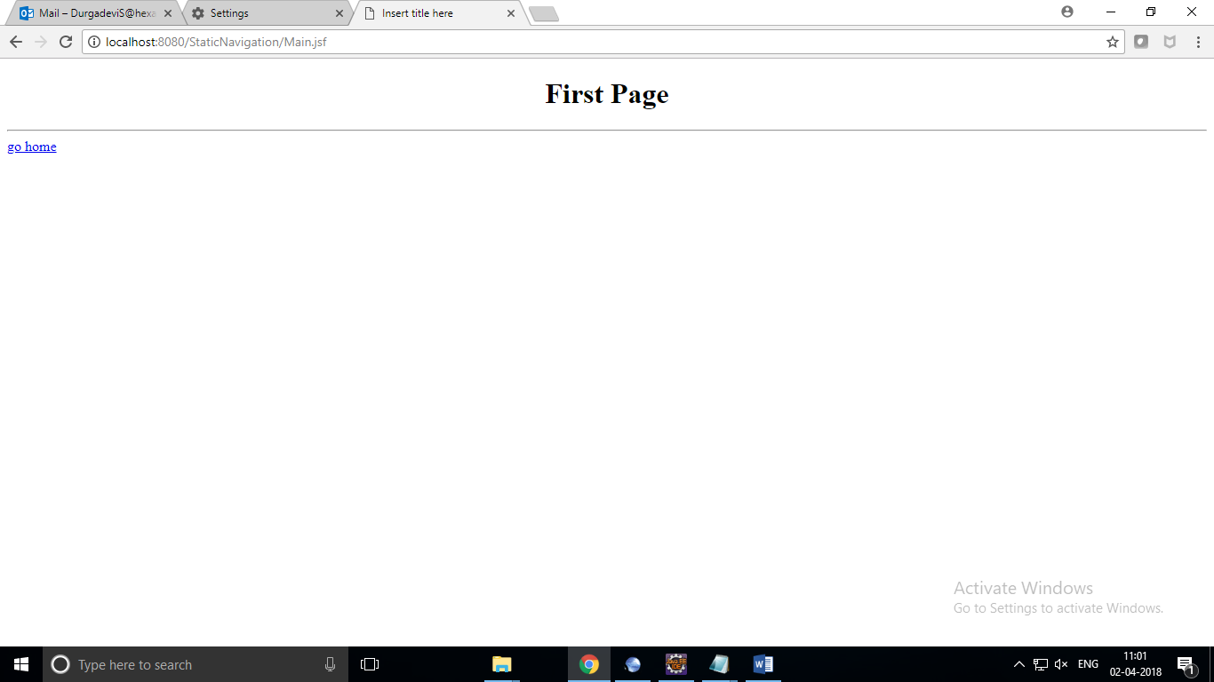

Go to home--🡪main page

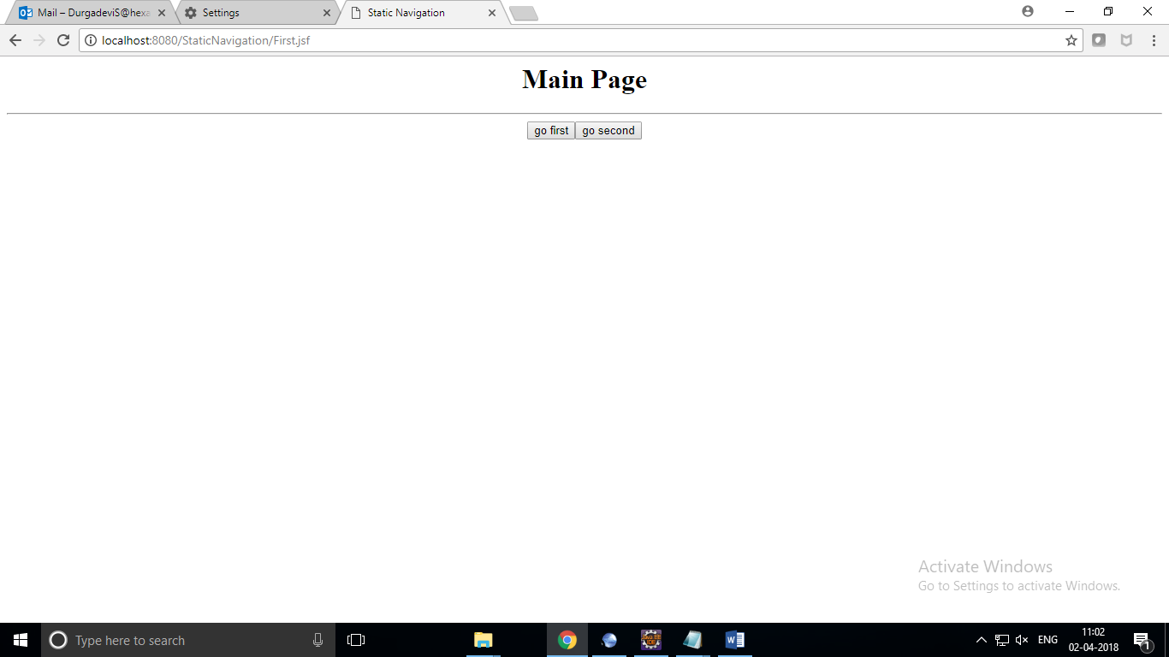

Source Code in Url

First.jsp

|  |  |
| --- | --- |
|  |  |
|  |  |
|  |  |
|  | <!DOCTYPE html> |
|  | <html> |
|  |  |
|  | <head> |
|  | <title>Insert title here</title> |
|  | </head> |
|  | <body> |
|  | <h1 align="center">First Page</h1> |
|  | <hr size="2" /> |
|  |  |
|  | <form id="j_id_jsp_826735369_1" name="j_id_jsp_826735369_1" method="post" action="/StaticNavigation/First.jsf" enctype="application/x-www-form-urlencoded"> |
|  | <input type="hidden" name="j_id_jsp_826735369_1" value="j_id_jsp_826735369_1" /> |
|  |  |
|  | <script type="text/javascript" src="[/StaticNavigation/javax.faces.resource/jsf.js.jsf?ln=javax.faces](http://localhost:8080/StaticNavigation/javax.faces.resource/jsf.js.jsf?ln=javax.faces)"></script> |
|  | <a href="[#](http://localhost:8080/StaticNavigation/Main.jsf)" onclick="mojarra.jsfcljs(document.getElementById('j_id_jsp_826735369_1'),{'j_id_jsp_826735369_1:j_id_jsp_826735369_2':'j_id_jsp_826735369_1:j_id_jsp_826735369_2'},'');return false">go home</a><input type="hidden" name="javax.faces.ViewState" id="javax.faces.ViewState" value="-3035671580577131307:1186833732897087704" autocomplete="off" /> |
|  | </form> |
|  | </body> |
|  |  |
|  | </html> |

----------it takes id for the form and input type name also-------------------

Taxcalculation

Taxfrm:

<%@ page language=*"java"* contentType=*"text/html; charset=UTF-8"*

pageEncoding=*"UTF-8"*%>

<%@taglib uri=*"http://java.sun.com/jsf/core"* prefix=*"f"*%>

<%@taglib uri=*"http://java.sun.com/jsf/html"* prefix=*"h"*%>

<!DOCTYPE >

<html>

<f:view>

<head>

<title>Tax Calculation</title>

<style>

**table**{

margin:*0 auto*;

border-collapse:*collapse*;

}

*.css1*{

background-color:*pink*;

}

</style>

</head>

<body>

<h1 align=*"center"*>Tax Calculation</h1>

<hr size=*"2"* />

<h:form id=*"tfrm"*>

<h:panelGrid id=*"pg1"* columns=*"3"* columnClasses=*"css1"* cellpadding=*"10"* bgcolor=*"wheat"*>

<h:outputText value=*"Employee Name"* />

<h:inputText id=*"name"* value=*"*#{tbean.ename }*"* required=*"true"*

requiredMessage=*"name is manadatory"* />

<h:message for=*"name"*></h:message>

<h:outputText value=*"Annual income"* />

<h:inputText id=*"income"* value=*"*#{tbean.income }*"* required=*"true"*

requiredMessage=*"income is manadatory"* />

<h:message for=*"income"*></h:message>

<h:commandButton value=*"calcTax"* action=*"*#{tbean.calcTax }*"* />

</h:panelGrid>

</h:form>

</f:view>

</body>

</html>

TaxSubmit.jsp:

<%@ page language=*"java"* contentType=*"text/html; charset=UTF-8"*

pageEncoding=*"UTF-8"*%>

<%@taglib uri=*"http://java.sun.com/jsf/core"* prefix=*"f"*%>

<%@taglib uri=*"http://java.sun.com/jsf/html"* prefix=*"h"*%>

<!DOCTYPE >

<html>

<f:view>

<head>

<title>Tax Calculation</title> //css style

<style>

**table**{

margin:*0 auto*;

border-collapse:*collapse*;

}

*.css1*{

background-color:*pink*;

}

</style>

</head>

<body>

<h:panelGrid columns=*"2"* columnClasses=*"css1"* bgcolor=*"wheat"* cellpadding=*"10"*>

<h:outputText value=*"Employee Name"*/>

<h:outputText value=*"*#{tbean.ename}*"*/>

<h:outputText value=*"Employee income"*/>

<h:outputText value=*"*#{tbean.income}*"*/>

<h:outputText value=*"Tax to be paid"*/>

<h:outputText value=*"*#{tbean.tax}*"*/>

</h:panelGrid>

</body>

</f:view>

</html>Face-config.xml:

<?xml version=*"1.0"* encoding=*"UTF-8"*?>

<faces-config xmlns=*"http://java.sun.com/xml/ns/javaee"*

xmlns:xsi=*"http://www.w3.org/2001/XMLSchema-instance"*

xsi:schemaLocation=*"http://java.sun.com/xml/ns/javaee*

*http://java.sun.com/xml/ns/javaee/web-facesconfig_2_0.xsd"*

version=*"2.0"*>

<managed-bean>

<managed-bean-name>tbean</managed-bean-name>

<managed-bean-class>com.hexa.bean.TaxBean</managed-bean-class>

<managed-bean-scope>request</managed-bean-scope>

</managed-bean>

<navigation-rule>

<from-view-id>/TaxFrm.jsp</from-view-id>

<navigation-case>

<from-outcome>success</from-outcome>

<to-view-id>TaxSubmit.jsp</to-view-id>

</navigation-case>

</navigation-rule>

</faces-config>

Web.xml:

<?xml version=*"1.0"* encoding=*"UTF-8"*?>

<web-app xmlns:xsi=*"http://www.w3.org/2001/XMLSchema-instance"* xmlns=*"http://java.sun.com/xml/ns/javaee"* xsi:schemaLocation=*"http://java.sun.com/xml/ns/javaee http://java.sun.com/xml/ns/javaee/web-app_3_0.xsd"* id=*"WebApp_ID"* version=*"3.0"*>

<display-name>DynamicNavigation</display-name>

<welcome-file-list>

<welcome-file>index.html</welcome-file>

<welcome-file>index.htm</welcome-file>

<welcome-file>index.jsp</welcome-file>

<welcome-file>default.html</welcome-file>

<welcome-file>default.htm</welcome-file>

<welcome-file>default.jsp</welcome-file>

</welcome-file-list>

<servlet>

<servlet-name>Faces Servlet</servlet-name>

<servlet-class>javax.faces.webapp.FacesServlet</servlet-class>

<load-on-startup>1</load-on-startup>

</servlet>

<servlet-mapping>

<servlet-name>Faces Servlet</servlet-name>

<url-pattern>*.jsf</url-pattern>

</servlet-mapping>

</web-app>

Taxbean.java;

**package** com.hexa.bean;

**public** **class** TaxBean {

**private** String ename;

**private** **double** income;

**private** **double** tax;

**public** String getEname() {

**return** ename;

}

**public** **void** setEname(String ename) {

**this**.ename = ename;

}

**public** **double** getIncome() {

**return** income;

}

**public** **void** setIncome(**double** income) {

**this**.income = income;

}

**public** **double** getTax() {

**return** tax;

}

**public** **void** setTax(**double** tax) {

**this**.tax = tax;

}

//action method

**public** String calcTax() {

**if**(income>1000000) {

**this**.tax=750000*0.1+(income-1000000)*0.15;

} **else** **if**(income>250000){

**this**.tax=(income-250000)*0.1;

}

**return** "success";

}

}

Output:

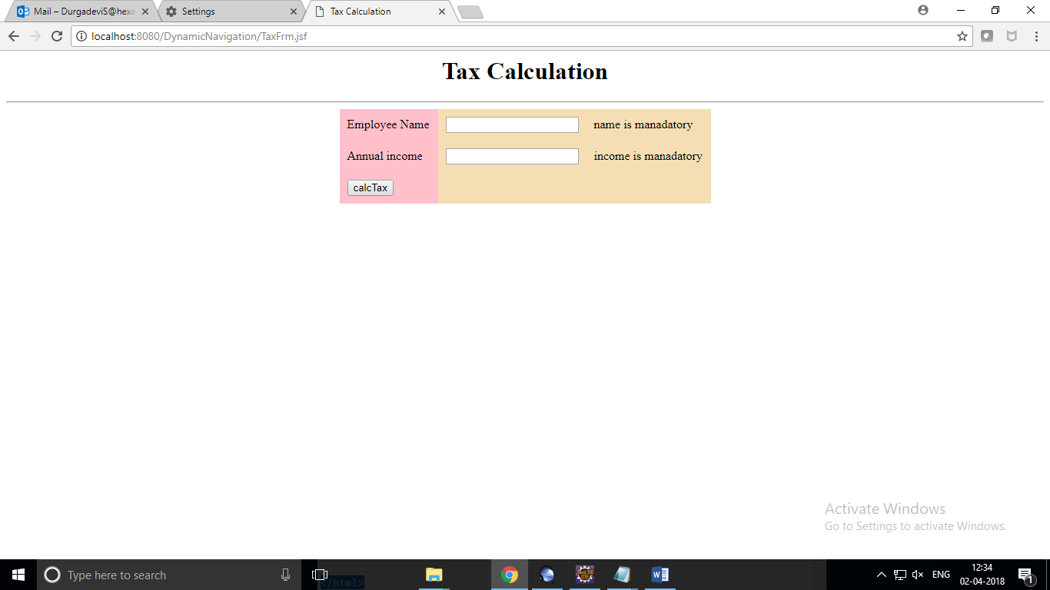

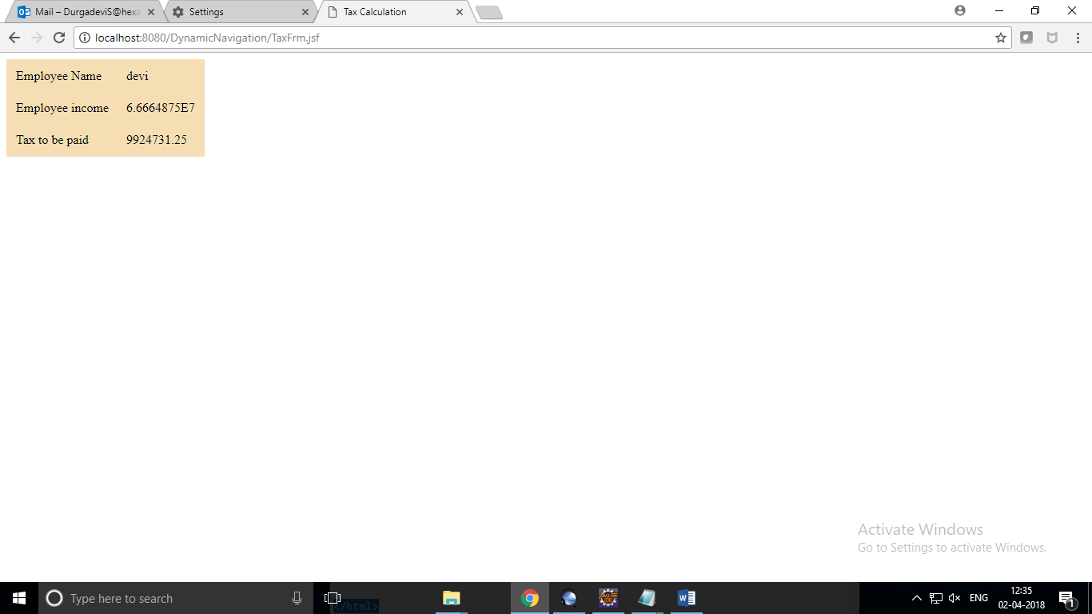

Life cycle:

TaxFrm.jsp:

<%@ page language=*"java"* contentType=*"text/html; charset=UTF-8"*

pageEncoding=*"UTF-8"*%>

<%@taglib uri=*"http://java.sun.com/jsf/core"* prefix=*"f"*%>

<%@taglib uri=*"http://java.sun.com/jsf/html"* prefix=*"h"*%>

<!DOCTYPE >

<html>

<f:view>

<head>

<title>Tax Calculation</title>

<style>

**table**{

margin:*0 auto*;

border-collapse:*collapse*;

}

*.css1*{

background-color:*pink*;

}

**tfoot,thead**{

background-color:*red*;

text-align:*center*;

color:*white*;

}

</style>

</head>

<body>

<h1 align=*"center"*>Tax Calculation</h1>

<hr size=*"2"* />

<h:form id=*"tfrm"*>

<h:panelGrid id=*"pg1"* columns=*"3"* columnClasses=*"css1"* cellpadding=*"10"* bgcolor=*"wheat"*>

<f:facet name=*"header"*>

<h:outputText value=*"Tax Form"*/>

</f:facet>

<h:outputText value=*"Employee Name"* />

<h:inputText id=*"name"* value=*"*#{tbean.ename }*"* required=*"true"*

requiredMessage=*"name is manadatory"* />

<h:message for=*"name"*></h:message>

<h:outputText value=*"Annual income"* />

<h:inputText id=*"income"* value=*"*#{tbean.income }*"* required=*"true"*

requiredMessage=*"income is manadatory"* />

<h:message for=*"income"*></h:message>

<f:facet name=*"footer"*>

<h:commandButton value=*"calcTax"* action=*"*#{tbean.calcTax }*"* />

</f:facet>

</h:panelGrid>

</h:form>

</f:view>

</body>

</html>

TAXSUBMIT.JSP:

<%@ page language=*"java"* contentType=*"text/html; charset=UTF-8"*

pageEncoding=*"UTF-8"*%>

<%@taglib uri=*"http://java.sun.com/jsf/core"* prefix=*"f"*%>

<%@taglib uri=*"http://java.sun.com/jsf/html"* prefix=*"h"*%>

<!DOCTYPE >

<html>

<f:view>

<head>

<title>Tax Calculation</title>

<style>

**table**{

margin:*0 auto*;

border-collapse:*collapse*;

}

*.css1*{

background-color:*pink*;

}

**tfoot,thead**{

background-color:re**d;**

**t**ext-align:*center*;

color:white;

}

</style>

</head>

<body>

<h:panelGrid columns=*"2"* columnClasses=*"css1"* bgcolor=*"wheat"* cellpadding=*"10"*>

<h:outputText value=*"Employee Name"*/>

<h:outputText value=*"*#{tbean.ename}*"*/>

<h:outputText value=*"Employee income"*/>

<h:outputText value=*"*#{tbean.income}*"*/>

<h:outputText value=*"Tax to be paid"*/>

<h:outputText value=*"*#{tbean.tax}*"*/>

</h:panelGrid>

</body>

</f:view>

</html>

MYPHASE listener:

package com.hexa.listener;

import javax.faces.event.PhaseEvent;

import javax.faces.event.PhaseId;

import javax.faces.event.PhaseListener;

public class MyPhaseListener implements PhaseListener {

@Override

public void afterPhase(PhaseEvent event) {

System.out.println("after "+ event.getPhaseId());

if(event.getPhaseId()== PhaseId.RENDER_RESPONSE){

System.out.println(event.getFacesContext().

getViewRoot().getViewId());

}

}

@Override

public void beforePhase(PhaseEvent event) {

System.out.println("before " + event.getPhaseId());

}

@Override

public PhaseId getPhaseId() {

return PhaseId.ANY_PHASE;

}

}

FACE-config.xml:

<?xml version=*"1.0"* encoding=*"UTF-8"*?>

<faces-config xmlns=*"http://java.sun.com/xml/ns/javaee"*

xmlns:xsi=*"http://www.w3.org/2001/XMLSchema-instance"*

xsi:schemaLocation=*"http://java.sun.com/xml/ns/javaee*

*http://java.sun.com/xml/ns/javaee/web-facesconfig_2_0.xsd"*

version=*"2.0"*>

<managed-bean>

<managed-bean-name>tbean</managed-bean-name>

<managed-bean-class>com.hexa.bean.TaxBean</managed-bean-class>

<managed-bean-scope>request</managed-bean-scope>

</managed-bean>

<navigation-rule>

<from-view-id>/TaxFrm.jsp</from-view-id>

<navigation-case>

<from-outcome>success</from-outcome>

<to-view-id>TaxSubmit.jsp</to-view-id>

</navigation-case>

</navigation-rule>

<lifecycle>

<phase-listener>com.hexa.listener.MyPhaseListener</phase-listener>

</lifecycle>

</faces-config>

TaxBean.java

**package** com.hexa.bean;

**public** **class** TaxBean {

**private** String ename;

**private** **double** income;

**private** **double** tax;

**public** TaxBean() {

System.***out***.println("constructor get invoked");

}

**public** String getEname() {

System.***out***.println("ename getter");

**return** ename;

}

**public** **void** setEname(String ename) {

System.***out***.println("ename is setter");

**this**.ename = ename;

}

**public** **double** getIncome() {

System.***out***.println("income getter");

**return** income;

}

**public** **void** setIncome(**double** income) {

System.***out***.println("income setter");

**this**.income = income;

}

**public** **double** getTax() {

System.***out***.println("tax getter");

**return** tax;

}

**public** **void** setTax(**double** tax) {

System.***out***.println("tax setter");

**this**.tax = tax;

}

//action method

**public** String calcTax() {

**if**(income>1000000) {

**this**.tax=750000*0.1+(income-1000000)*0.15;

} **else** **if**(income>250000){

**this**.tax=(income-250000)*0.1;

}

**return** "success";

}

}

Output:

Going to the page:

Following excetued:

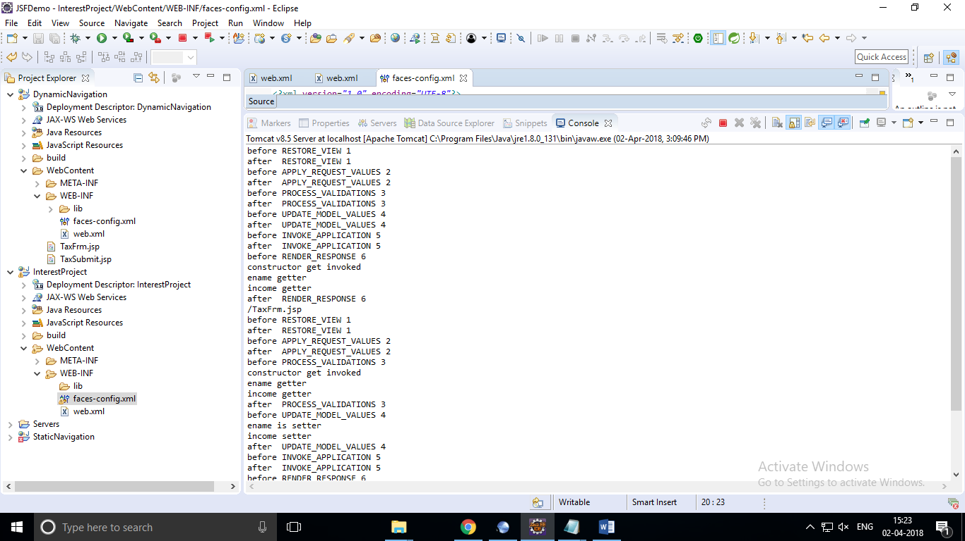

Simple interest and compound interest:

InterestBean.java

**package** com.hexa.bean;

**public** **class** InterestBean {

**private** **double** amount;

**private** **int** years;

**private** **double** rate;

**private** **double** si;

**private** String resCaption;

**public** String getResCaption() {

**return** resCaption;

}

**public** **void** setResCaption(String resCaption) {

**this**.resCaption = resCaption;

}

**public** **void** setRate(**double** rate) {

**this**.rate = rate;

}

**public** **double** getAmount() {

**return** amount;

}

**public** **void** setAmount(**double** amount) {

**this**.amount = amount;

}

**public** **int** getYears() {

**return** years;

}

**public** **void** setYears(**int** years) {

**this**.years = years;

}

**public** **double** getRate() {

**return** rate;

}

**public** **double** getSi() {

**return** si;

}

**public** **void** setSi(**double** si) {

**this**.si = si;

}

**public** String SimpleInterest() {

**this**.si=(amount *rate*years)/100;

**this**.resCaption="simple interest";

**return** "simple";

}

**public** String CompoundInterest() {

**this**.si=amount*

(Math.*pow*((1 + rate / 100), years));

**this**.resCaption="compound Interest";

**return** "compound";

}

}

Main.jsp

<%@ page language=*"java"* contentType=*"text/html; charset=UTF-8"*

pageEncoding=*"UTF-8"*%>

<%@taglib uri=*"http://java.sun.com/jsf/core"* prefix=*"f"*%>

<%@taglib uri=*"http://java.sun.com/jsf/html"* prefix=*"h"*%>

<!DOCTYPE >

<html>

<f:view>

<head>

<title>Interest Calculation</title>

</head>

<style>

**table**{

margin:*0 auto*;

border-collapse:*collapse*;

}

*.css1*{

background-color:*pink*;

}

**tfoot,thead**{

background-color:*red*;

text-align:*center*;

color:*white*;

}

</style>

</head>

<body>

<h1 align=*"center"*>Interest Calculation</h1>

<hr size=*"2"* />

<h:form id=*"tfrm"*>

<h:panelGrid id=*"pg1"* columns=*"3"* columnClasses=*"css1"* cellpadding=*"10"* bgcolor=*"wheat"*>

<f:facet name=*"header"*>

<h:outputText value=*"Interest Calculation"*/>

</f:facet>

<h:outputText value=*"Amount"* />

<h:inputText id=*"amount"* value=*"*#{tbean.amount }*"* required=*"true"*

requiredMessage=*"amount is manadatory"* validatorMessage=*"amount should greater than 5000"* >

<f:validateDoubleRange minimum=*"5000"*></f:validateDoubleRange>

</h:inputText>

<h:message for=*"amount"*></h:message>

<h:outputText value=*"rate"* />

<h:inputText id=*"rate"* value=*"*#{tbean.rate }*"* required=*"true"*

requiredMessage=*"rate is manadatory"* validatorMessage=*"rate should be 1 to 35"* >

<f:validateDoubleRange minimum=*"1"* maximum=*"35"*></f:validateDoubleRange>

</h:inputText>

<h:message for=*"rate"*></h:message>

<h:outputText value=*"years"* />

<h:inputText id=*"years"* value=*"*#{tbean.years }*"* required=*"true"*

requiredMessage=*"years is manadatory"* validatorMessage=*"years should be 1 to 30"*>

<f:validateLongRange minimum=*"1"* maximum=*"30"*></f:validateLongRange>

</h:inputText>

<h:message for=*"years"*></h:message>

<f:facet name=*"footer"*>

<h:panelGroup>

<h:commandButton value=*"SimpleInterest"* action=*"*#{tbean.SimpleInterest }*"* />&nbsp;

<h:commandButton value=*"CompoundInterest"* action=*"*#{tbean.CompoundInterest }*"* />

</h:panelGroup>

</f:facet>

</h:panelGrid>

</h:form>

</f:view>

</body>

</html>

Intersub.jsp:

</html><%@ page language=*"java"* contentType=*"text/html; charset=UTF-8"*

pageEncoding=*"UTF-8"*%>

<%@taglib uri=*"http://java.sun.com/jsf/core"* prefix=*"f"*%>

<%@taglib uri=*"http://java.sun.com/jsf/html"* prefix=*"h"*%>

<!DOCTYPE >

<html>

<f:view>

<head>

<title>Tax Calculation</title>

<style>

**table** {

margin: *0 auto*;

border-collapse: *collapse*;

}

*.css1* {

background-color: *pink*;

}

**tfoot,** **thead** {

background-color: *red*;

text-align: *center*;

color: *white*;

}

</style>

</head>

<body>

<h:panelGrid id=*"pg1"* columns=*"2"* columnClasses=*"css1"*

cellpadding=*"10"* bgcolor=*"wheat"*>

<f:facet name=*"header"*>

<h:outputText value=*"Interest Calculation"* />

</f:facet>

<h:outputText value=*"amount"* />

<h:outputText value=*"*#{tbean.amount}*"* />

<h:outputText value=*"rate"* />

<h:outputText value=*"*#{tbean.rate}*"* />

<h:outputText value=*"years"* />

<h:outputText value=*"*#{tbean.years}*"* />

<h:outputText value=*"*#{tbean.resCaption}*"* />

<h:outputText value=*"*#{tbean.si}*"*>

<f:convertNumber minFractionDigits=*"2"* maxFractionDigits=*"2"* />

</h:outputText>

</h:panelGrid>

</body>

</f:view>

</html>

Faces-config.xml:

<?xml version=*"1.0"* encoding=*"UTF-8"*?>

<faces-config xmlns=*"http://java.sun.com/xml/ns/javaee"*

xmlns:xsi=*"http://www.w3.org/2001/XMLSchema-instance"*

xsi:schemaLocation=*"http://java.sun.com/xml/ns/javaee*

*http://java.sun.com/xml/ns/javaee/web-facesconfig_2_0.xsd"*

version=*"2.0"*>

<managed-bean>

<managed-bean-name>tbean</managed-bean-name>

<managed-bean-class>com.hexa.bean.InterestBean</managed-bean-class>

<managed-bean-scope>request</managed-bean-scope>

</managed-bean>

<navigation-rule>

<from-view-id>/Main.jsp</from-view-id>

<navigation-case>

<from-outcome>simple</from-outcome>

<to-view-id>InterSub.jsp</to-view-id>

</navigation-case>

</navigation-rule>

<navigation-rule>

<from-view-id>/Main.jsp</from-view-id>

<navigation-case>

<from-outcome>compound</from-outcome>

<to-view-id>InterSub.jsp</to-view-id>

</navigation-case>

</navigation-rule>

</faces-config>

Web.xml:

<?xml version=*"1.0"* encoding=*"UTF-8"*?>

<web-app xmlns:xsi=*"http://www.w3.org/2001/XMLSchema-instance"* xmlns=*"http://java.sun.com/xml/ns/javaee"* xsi:schemaLocation=*"http://java.sun.com/xml/ns/javaee http://java.sun.com/xml/ns/javaee/web-app_3_0.xsd"* id=*"WebApp_ID"* version=*"3.0"*>

<display-name>InterestProject</display-name>

<welcome-file-list>

<welcome-file>index.html</welcome-file>

<welcome-file>index.htm</welcome-file>

<welcome-file>index.jsp</welcome-file>

<welcome-file>default.html</welcome-file>

<welcome-file>default.htm</welcome-file>

<welcome-file>default.jsp</welcome-file>

</welcome-file-list>

<servlet>

<servlet-name>Faces Servlet</servlet-name>

<servlet-class>javax.faces.webapp.FacesServlet</servlet-class>

<load-on-startup>1</load-on-startup>

</servlet>

<servlet-mapping>

<servlet-name>Faces Servlet</servlet-name>

<url-pattern>*.jsf</url-pattern>

</servlet-mapping>

</web-app>

Output:

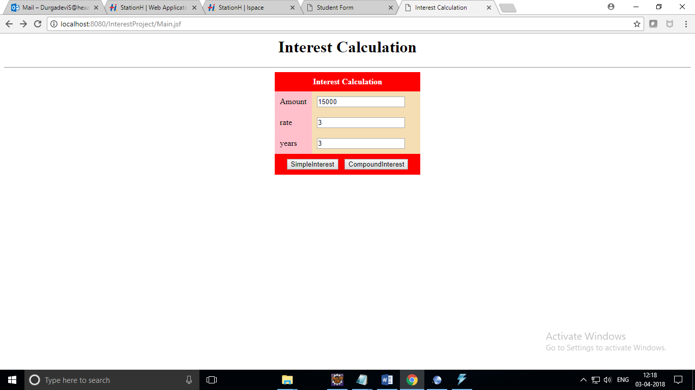

SimpleInterest:

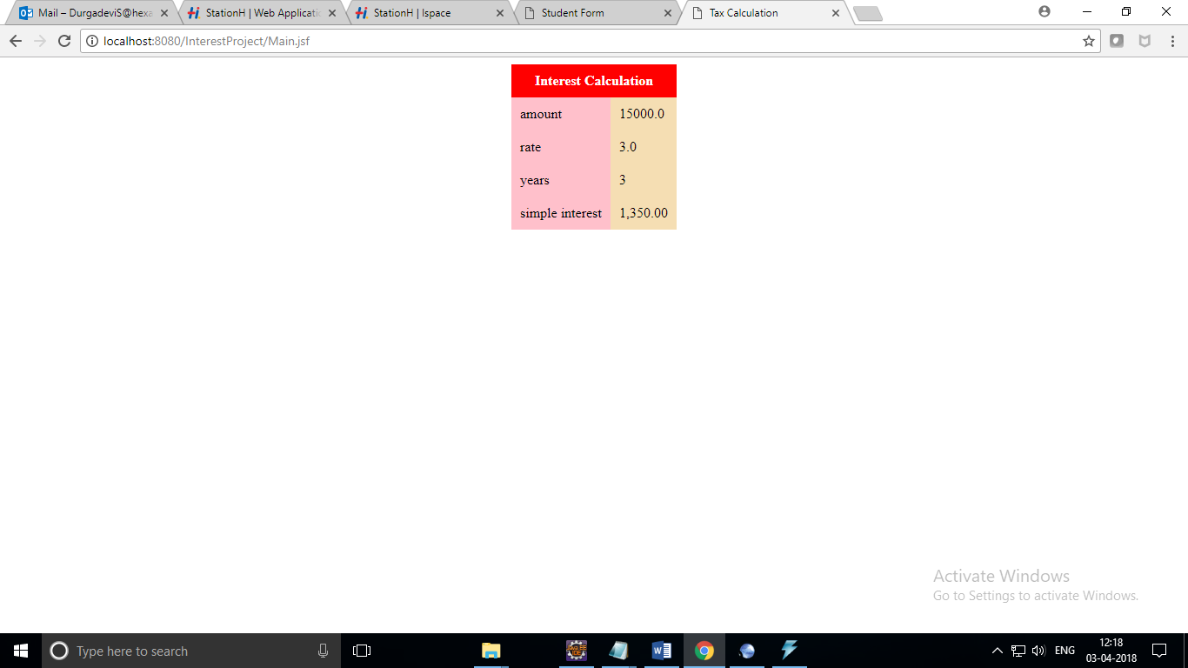

Compound interest:

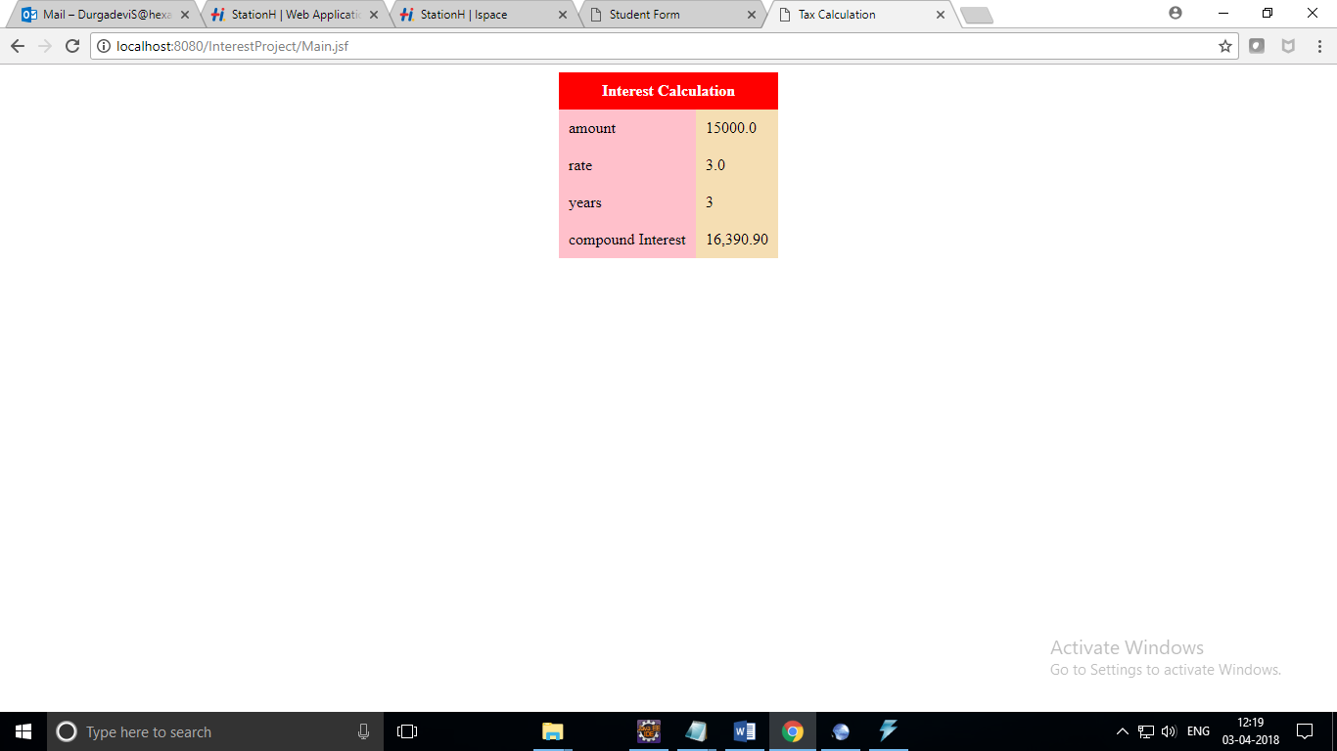

Dependency injection:

Dao:

Idao(interface):

**package** com.hexa.dao;

**import** java.util.List;

**import** com.hexa.entity.Student;

**public** **interface** IDao {

**public** **int** addStudent(Student stu);

**public** Student getStudent(**int** sid);

**public** **int** updateStudent(**int** sid, **int** marks);

**public** **int** updateStudent(Student stu);

**public** **int** deleteStudent(**int** sid);

**public** List<Student> getStudent();

**public** List<Student> getStudent(String dept);

}

idaoImpl:

package com.hexa.dao;

import java.util.List;

import org.hibernate.HibernateException;

import org.hibernate.Query;

import org.hibernate.Session;

import org.hibernate.SessionFactory;

import org.hibernate.Transaction;

import org.hibernate.cfg.AnnotationConfiguration;

import org.hibernate.cfg.Configuration;

import com.hexa.entity.Student;

public class DaoImp1 implements IDao {

private static SessionFactory sfac;

static {

Configuration cfg = new AnnotationConfiguration();

cfg.configure();//loads hiberate.cfg.xml

sfac= cfg.buildSessionFactory();

}

@Override

public int addStudent(Student stu) {

Session sess=null;

Transaction tx = null;

try {

sess =sfac.openSession();

tx=sess.beginTransaction();

sess.save(stu);

tx.commit();

return 1;

} catch(HibernateException ex) {

System.out.println(ex.getMessage());

if(tx!=null) {

tx.rollback();

}

} finally {

if(sess!=null){

sess.close();

}

}

return 0;

}

@Override

public Student getStudent(int sid) {

Session sess = sfac .openSession();

Student stu = (Student) sess.get(Student.class, sid);

sess.close();

return stu;

}

@Override

public int updateStudent(int sid, int marks) {

Session sess = sfac.openSession();

Student stu =(Student)sess.get(Student.class, sid);

Transaction tx = sess.beginTransaction();

stu.setMarks(marks);

tx.commit();

sess.close();

return 0;

}

@Override

public int deleteStudent(int sid) {

Session sess = sfac.openSession();

Student stu =(Student)sess.get(Student.class, sid);

Transaction tx = sess.beginTransaction();

try {

sess.delete(stu);

tx.commit();

return 1;

} catch (HibernateException e) {

System.out.println(e.getMessage());

}

//System.out.println(stu);

sess.close();

return 0;

}

@Override

public int updateStudent(Student stu) {

Session sess = sfac.openSession();

Transaction tx = sess.beginTransaction();

try {

sess.saveOrUpdate(stu);

tx.commit();

return 1;

} catch (HibernateException e) {

System.out.println(e.getMessage());

}

sess.close();

return 0;

}

@Override

public List<Student> getStudent() {

Session sess=sfac.openSession();

Query qry=sess.createQuery("from Student s");

List<Student> lst= qry.list();

sess.close();

return lst;

}

@Override

public List<Student> getStudent(String dept) {

Session sess=sfac.openSession();

Query qry=sess.createQuery("from Student s where dept");

qry.setParameter(0, dept);

List<Student> lst= qry.list();

sess.close();

return lst;

}

}

Student.java

package com.hexa.entity;

import java.util.Date;

import javax.persistence.Column;

import javax.persistence.Entity;

import javax.persistence.Id;

import javax.persistence.Table;

@Entity // to say hibernate that we using java class to map type table

@Table(name="student")//it should map to student table

public class Student {

@Id //specifying the primary key

@Column(name="stu_id")

private int stuId;

@Column(name="stu_name", length=45)

private String stName;

@Column(name="stu_dept", length=10)

private String dept;

@Column(name="stu_dob")

private Date dob;

@Column(name="stu_marks")

private int marks;

public int getStuId() {

return stuId;

}

@Override

public String toString() {

return "Student [stuId=" + stuId + ", StName=" + stName + ", dept=" + dept + ", dob=" + dob + ", marks=" + marks

+ "]";

}

public void setStuId(int stuId) {

this.stuId = stuId;

}

public String getStName() {

return stName;

}

public void setStName(String stName) {

this.stName = stName;

}

public String getDept() {

return dept;

}

public void setDept(String dept) {

this.dept = dept;

}

public Date getDob() {

return dob;

}

public void setDob(Date dob) {

this.dob = dob;

}

public int getMarks() {

return marks;

}

public void setMarks(int marks) {

this.marks = marks;

}

}

MyPhaselistener.java:

package com.hexa.listener;

import javax.faces.event.PhaseEvent;

import javax.faces.event.PhaseId;

import javax.faces.event.PhaseListener;

public class MyPhaseListener implements PhaseListener {

@Override

public void afterPhase(PhaseEvent event) {

System.out.println("after "+ event.getPhaseId());

if(event.getPhaseId()== PhaseId.RENDER_RESPONSE){

System.out.println(event.getFacesContext().

getViewRoot().getViewId());

}

}

@Override

public void beforePhase(PhaseEvent event) {

System.out.println("before " + event.getPhaseId());

}

@Override

public PhaseId getPhaseId() {

return PhaseId.ANY_PHASE;

}

}

StudentBean.java

**package** com.hexa.web;

**import** java.util.List;

**import** javax.faces.event.ActionEvent;

**import** com.hexa.dao.IDao;

**import** com.hexa.entity.Student;

**public** **class** StudentBean {

**private** List<Student> slist;

**private** IDao dao;

**private** **int** sid;

**private** Student stu;

**private** **boolean** panelFlag;

**public** **boolean** isPanelFlag() {

**return** panelFlag;

}

**public** **void** setPanelFlag(**boolean** panelFlag) {

**this**.panelFlag = panelFlag;

}

**public** Student getStu() {

**return** stu;

}

**public** **void** setStu(Student stu) {

**this**.stu = stu;

}

**public** **int** getSid() {

**return** sid;

}

**public** **void** setSid(**int** sid) {

**this**.sid = sid;

}

**public** List<Student> getSlist() {

**this**.slist=dao.getStudent();

**return** slist;

}

//setter for injection by jsf

**public** **void** setDao(IDao dao) {

**this**.dao = dao;

}

//action listener method

**public** **void** viewById(ActionEvent ae) {

**this**.stu= dao.getStudent(sid);

**if**(**this**.stu!=**null**) {

**this**.panelFlag=**false**;

} **else** {

**this**.panelFlag=**true**;

}

}

}

Hibernate-cfg.xml:

<?xml version=*'1.0'* encoding=*'utf-8'*?>

<!DOCTYPE hibernate-configuration PUBLIC

"-//Hibernate/Hibernate Configuration DTD//EN"

"http://hibernate.sourceforge.net/hibernate-configuration-3.0.dtd">

<hibernate-configuration>

<session-factory>

<property name=*"hibernate.connection.driver_class"*>

com.mysql.jdbc.Driver</property>

<property name=*"hibernate.connection.url"*>

jdbc:mysql://localhost:3306/test</property>

<property name=*"hibernate.connection.username"*>root</property>

<property name=*"hibernate.connection.password"*>root</property>

<property name=*"hibernate.connection.pool_size"*>5</property>

<property name=*"hibernate.show_sql"*>true</property>

<property name=*"hibernate.format_sql"*>false</property>

<property name=*"hibernate.dialect"*>org.hibernate.dialect.MySQLDialect</property>

<property name=*"hibernate.hbm2ddl.auto"*>update</property>

<!-- <mapping resource="product.hbm.xml" /> -->

<mapping class=*"com.hexa.entity.Student"*/>

</session-factory>

</hibernate-configuration>

Face-config.xml

<?xml version=*"1.0"* encoding=*"UTF-8"*?>

<faces-config xmlns=*"http://java.sun.com/xml/ns/javaee"*

xmlns:xsi=*"http://www.w3.org/2001/XMLSchema-instance"*

xsi:schemaLocation=*"http://java.sun.com/xml/ns/javaee*

*http://java.sun.com/xml/ns/javaee/web-facesconfig_2_0.xsd"*

version=*"2.0"*>

<managed-bean>

<managed-bean-name>studao</managed-bean-name>

<managed-bean-class>com.hexa.dao.DaoImp1</managed-bean-class>

<managed-bean-scope>application</managed-bean-scope>

</managed-bean>

<managed-bean>

<managed-bean-name>sbean</managed-bean-name>

<managed-bean-class>com.hexa.web.StudentBean</managed-bean-class>

<managed-bean-scope>request</managed-bean-scope>

<managed-property>

<property-name>dao</property-name>

<value>#{studao}</value>

</managed-property>

</managed-bean>

<lifecycle>

<phase-listener>com.hexa.listener.MyPhaseListener</phase-listener>

</lifecycle>

</faces-config>

Web.xml:

<?xml version=*"1.0"* encoding=*"UTF-8"*?>

<web-app xmlns:xsi=*"http://www.w3.org/2001/XMLSchema-instance"* xmlns=*"http://java.sun.com/xml/ns/javaee"* xsi:schemaLocation=*"http://java.sun.com/xml/ns/javaee http://java.sun.com/xml/ns/javaee/web-app_3_0.xsd"* id=*"WebApp_ID"* version=*"3.0"*>

<display-name>DependencyInjection</display-name>

<welcome-file-list>

<welcome-file>index.html</welcome-file>

<welcome-file>index.htm</welcome-file>

<welcome-file>index.jsp</welcome-file>

<welcome-file>default.html</welcome-file>

<welcome-file>default.htm</welcome-file>

<welcome-file>default.jsp</welcome-file>

</welcome-file-list>

<servlet>

<servlet-name>Faces Servlet</servlet-name>

<servlet-class>javax.faces.webapp.FacesServlet</servlet-class>

<load-on-startup>1</load-on-startup>

</servlet>

<servlet-mapping>

<servlet-name>Faces Servlet</servlet-name>

<url-pattern>*.jsf</url-pattern>

</servlet-mapping>

</web-app>

Studentbyid.jsf:

<%@ page language=*"java"* contentType=*"text/html; charset=UTF-8"*

pageEncoding=*"UTF-8"*%>

<%@taglib uri=*"http://java.sun.com/jsf/core"* prefix=*"f"*%>

<%@taglib uri=*"http://java.sun.com/jsf/html"* prefix=*"h"*%>

<!DOCTYPE >

<html>

<f:view>

<head>

<title>Student Form</title>

<style>

**table** {

margin: *0 auto*;

border-collapse: *collapse*;

}

*.head* {

background-color: *red*;

color: *white*;

}

*.css1* {

background-color: *pink*;

}

</style>

</head>

<body>

<h1 align=*"center"*>Student Form</h1>

<hr size=*"2"*>

<h:form id=*"tfrm"*>

<div align=*"center"*>

<h:outputText value=*"Student Id"* />

<h:inputText value=*"*#{sbean.sid }*"*></h:inputText>

<h:commandButton value=*"search"* actionListener=*"*#{sbean.viewById}*"* />

</h:form>

<hr size=*"2"*>

<h:panelGrid id=*"pg1"* columns=*"2"* columnClasses=*"css1"*

cellpadding=*"10"* bgcolor=*"wheat"*>

<h:outputText value=*"Student Id"* />

<h:outputText value=*"*#{sbean.stu.stuId}*"* />

<h:outputText value=*"Student Name"* />

<h:outputText value=*"*#{sbean.stu.stName}*"* />

<h:outputText value=*"Student marks"* />

<h:outputText value=*"*#{sbean.stu.marks}*"* />

<h:outputText value=*"Student depart"* />

<h:outputText value=*"*#{sbean.stu.dept}*"* />

<h:outputText value=*"Date Of Birth"* />

<h:outputText value=*"*#{sbean.stu.dob}*"*>

<f:convertDateTime pattern=*"dd/MM/yyyy"* />

</h:outputText>

</h:panelGrid>

<h:panelGrid bgcolor=*"wheat"* rendered=*"*#{sbean.panelFlag}*"*>

<f:facet name=*"header"*>

<h:outputText value=*""*></h:outputText>

</f:facet>

<h:outputText value=*"no such student"*></h:outputText>

</h:panelGrid>

</body>

</f:view>

</html>

StudentView.jsp:

<%@ page language=*"java"* contentType=*"text/html; charset=UTF-8"*

pageEncoding=*"UTF-8"*%>

<%@taglib uri=*"http://java.sun.com/jsf/core"* prefix=*"f"*%>

<%@taglib uri=*"http://java.sun.com/jsf/html"* prefix=*"h"*%>

<!DOCTYPE >

<html>

<f:view>

<head>

<title>Student details</title>

<style>

**table** {

margin: *0 auto*;

border-collapse: *collapse*;

}

*.head*{

background-color:*red*;

color:*white*;

}

*.odd* {

background-color: *pink*;

}

*.even*{

background-color:*wheat*;

}

</style>

</head>

<body>

<h1 align=*"center"*>Student Details</h1>

<hr size=*"2"* />

<h:dataTable value=*"*#{sbean.slist}*"* var=*"s"* cellpadding=*"10"* headerClass=*"head"* rowClasses=*"even,odd"*>

<h:column>

<f:facet name=*"header"*>

<h:outputText value=*"Student Id"* />

</f:facet>

<h:outputText value=*"*#{s.stuId}*"*></h:outputText>

</h:column>

<h:column>

<f:facet name=*"header"*>

<h:outputText value=*"Student Name"* />

</f:facet>

<h:outputText value=*"*#{s.stName}*"*></h:outputText>

</h:column>

<h:column>

<f:facet name=*"header"*>

<h:outputText value=*"Student marks"* />

</f:facet>

<h:outputText value=*"*#{s.marks}*"*></h:outputText>

</h:column>

<h:column>

<f:facet name=*"header"*>

<h:outputText value=*"Department"* />

</f:facet>

<h:outputText value=*"*#{s.dept}*"*></h:outputText>

</h:column>

<h:column>

<f:facet name=*"header"*>

<h:outputText value=*"Date Of Birth"* />

</f:facet>

<h:outputText value=*"*#{s.dob}*"*>

<f:convertDateTime pattern=*"dd-MM-yyy"*/>

</h:outputText>

</h:column>

</h:dataTable>

</body>

</f:view>

</html>

Output:

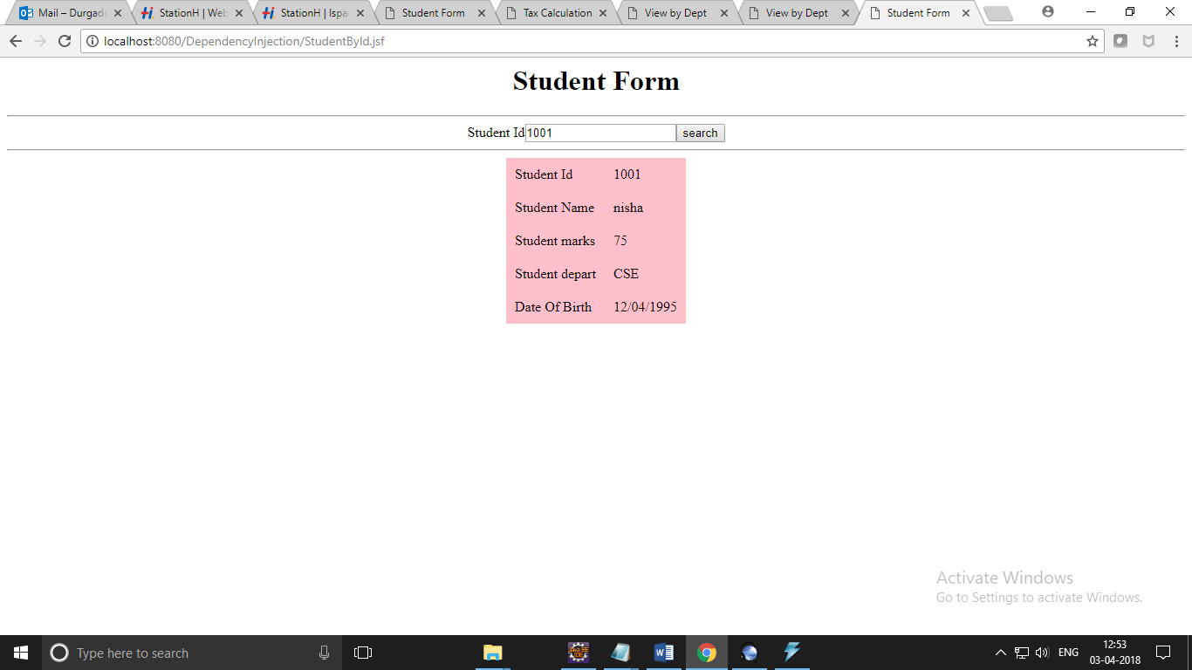

Input:8948645213(wrd id)

